Electronic Supplementary Information

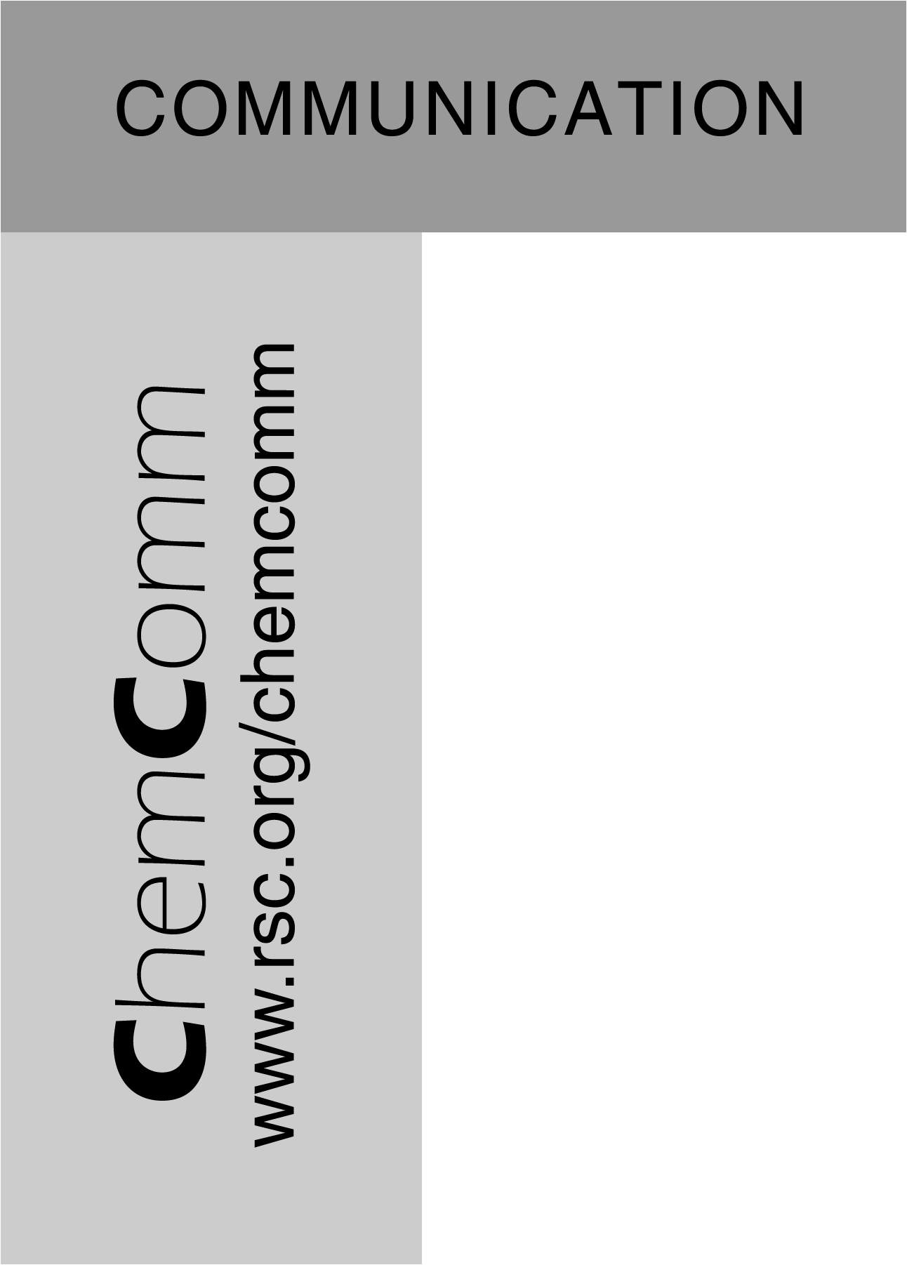
Novel Solvent Properties of Choline Chloride/ Urea Mixtures
Andrew P. Abbott*, Glen Capper, David L. Davies, Raymond K. Rasheed and Vasuki Tambyrajah
ª Chemistry Department, University of Leicester, Leicester, UK, LE1 7RH. Fax: 116 252 3789; Tel: 116 252 2087; E-mail: Andrew.abbott@le.ac.uk

Spectroscopic Information on Choline Chloride (CC): 2Urea mixture

¹H nmr (40 °C):- Me₃, 9H, s, 3.42; α-CH₂, 2H, m, 3.73; β-CH₂, 2H, m, 4.18; OH, 1H, v. broad, 5.50; NH₂, 8H, broad, 6.24

¹³C {¹H} nmr (50 °C):- Me₃ 54.40; α-CH₂ 56.26; β-CH₂ 68.20; C(urea) 162.21

³⁵Cl nmr (50 °C):- +44.493, broad (wrt NaCl in water)

FAB-MS ran neat without matrix present
M⁺ - 104 [Choline]⁺
M⁻ - 155 (Cl⁻ + 2urea) very weak; 95 (Cl⁻ + urea) weak

IR
C=O (Urea) 1681.3 and 1637.5 (Urea in Nujol mull) shifted to 1669.0 1618.4 cm⁻¹ (2Urea: 1CC) respectively.

Physical properties
Surface tension | 52.02±0.05 mN/m (25.0±0.2 °C)
Density | 1.24gcm⁻³ (45 °C)
Refractive index | 1.504

Spectroscopic Information on Choline Fluoride: 2Urea mixture

HOESY Spectrum of CF: 2Urea – Intense Correlation between F- and Urea protons

¹H nmr (40 °C):- Me₃, 9H, s, 3.26; α-CH₂, 2H, m, 3.57; β-CH₂, 2H, m, 4.00; NH₂, 8H, broad, 6.27; OH, 1H, v. broad, 6.83
¹⁹F nmr –110.2ppm

